Interactive Pervasive Computing (STW30CR-S20)

Group Project Report

ON

Smart City with Smart Traffic

Submitted by: Submitted To:

Anish Nepal Mr. Hikmat Saud

Bhanubhakta Bhandari

Nishchit Shah

Sabin Chapagain

Unish Bhattarai

# Introduction

Smart City with Smart Traffic is all about a plan developed to enhance the present condition of traffic inside a city to ensure the better quality of people travelling and people standing to manage the traffic. Problem facing due to traffic is one of the major problems inside the city nowadays. Problems like traffic congestion, over speeding and unmanaged parking are some of the problems that are to be solved. With the various types of sensors for different purpose are used within the prototype to manage the traffic problems. Ultrasonic sensors for detecting the traffic congestion and diverging the way to the travelers, RFID for detecting the over speeding vehicles and collecting the data in Firebase (Real time database) and IR sensors to manage the parking.

# Aims

Building a prototype exploring the problem, of our daily life in any city area, along with the solution by using different tools and technologies is the main aim of this project.

# Objectives

1. To allocate the tasks for each member in the group.
2. To design and develop the system for congestion detection.
3. To design and develop the system for speed detection.
4. To design and develop the system for smart parking.
5. To implement the designed system in the prototype.
6. To design and develop the prototype as per plan.

# Justification

**Scenario - 1:**

First two picture describes the problem, and another two picture describes the solution. The first two picture portray the state that one officer is leaving for office. On the way to his/her office he/she stuck into traffic jam from where he/she can neither move forward nor backward. He/She will surely become late for his/her office.

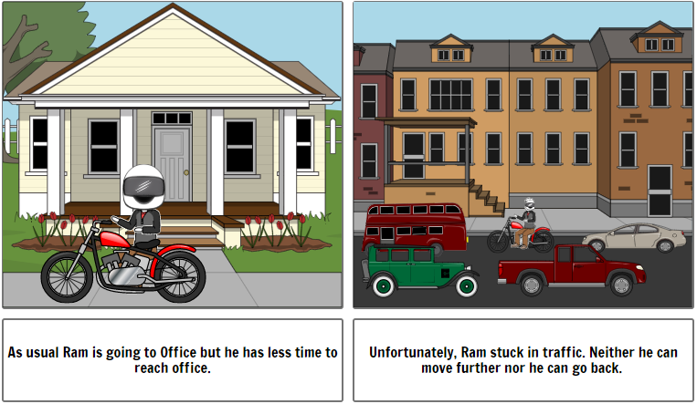

Figure 1: Traffic Jam.

As we are facing this problem since very long so we decided to implement Ultrasonic Sensor on the road from its starting point to ending point. If both of that sensors sense some object from very long time then it will display "Traffic Jam on this way" and barrier gets down so that no any vehicle can enter from that road which helps to other people to take diversion from that road.

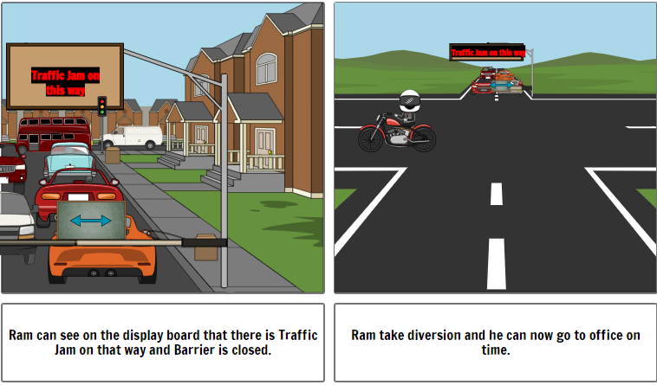

Figure 2: Traffic Jam Solution

**Scenario – 2:**

Below two picture portrays problem of over speeding in speed limit area and two pictures shows the solution for it. One of a bike rider sees that road is straight so he speed up on that road but there is a speed limit board of 10km/hr because that is hospital area. Traffic is telling him to stop but he did not stop and move far away from traffic and his bike number plate is not visible to traffic so that he is not fined.

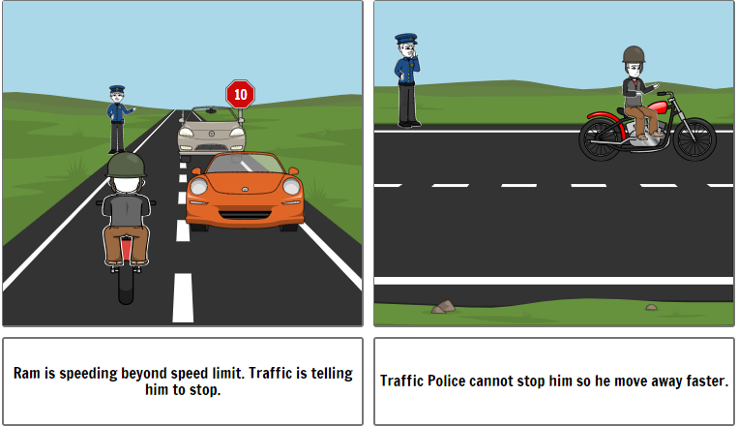

Figure 3: Over speeding Problem

So, for overcoming this problem we have implemented RFID Sensor under the road which reads the personal info stored on the RFID Card or RFID Tag implemented in vehicles from manufacture when vehicles passed over that sensors and calculates speed of that particular vehicle and it will be stored in traffic police's sever.

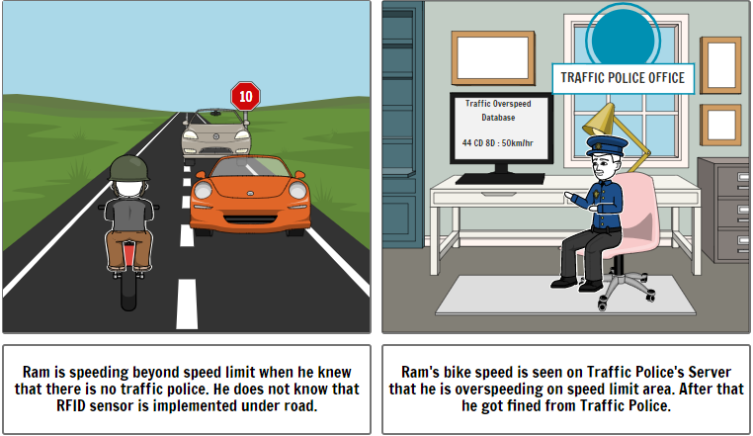

Figure 4: Over speeding Solution

**Scenario – 3:**

The first picture portrays the parking problem and below two picture with its solution. As seen on that picture, one person entered into parking area for parking his vehicle but came out of that parking area because parking lot is full so that he has to search for another parking area. He lost his time after entering into that parking area.

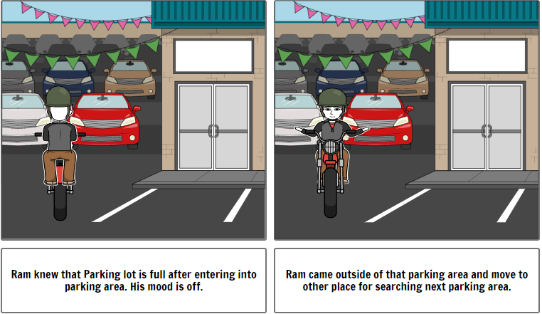

Figure 5: Parking Problem

So for its solution we have use IR sensor to increase the count of vehicle on entering and decrease count of vehicle on exit and displaying on the display outside parking area that how much slot is available in parking area which helps people to know if that parking is full or not. If it is full or empty then people can know from display outside on display board so that he can search for new parking without entering into it.

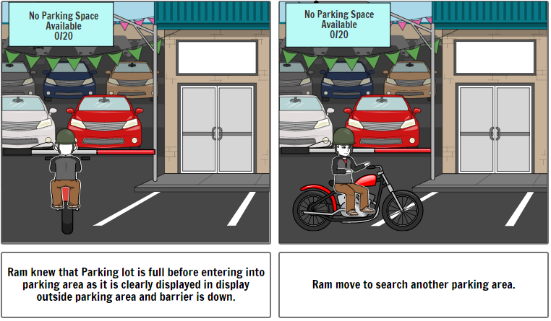

Figure 6: Parking Solution

# Research and Plan

Requirement gathering is the first thing we have done where we have collected and documented different requirements which helped us to understand what we are building. It defines how the system should perform the task under different conditions. All team members collected different ideas by using brainstorming technique and analysis from different research papers of smart city and smart traffic management system.

Before starting the prototype of the system, we gained some knowledge about the various sensors and devices that can be used to build the prototype of our system. After the study of different equipment’s, we have selected some sensors which were applicable and affordable for developing our prototype of smart city with smart traffic system. We have three scenarios in this prototype where we have used three different sensors.

In the city like Kathmandu where there are lot of vehicles which causes hours of traffic jam, we thought of creating a prototype to solve this problem by automating the jam detection. We have used ultrasonic sensors to detect vehicles within a certain range to detect traffic jams. The LCD screen is applied to show if there is a traffic jam ahead and if there is a traffic jam the road is blocked with the help of a servo motor.

To detect the speed, RFID is used. An RFID tag is embedded in the vehicle and an RFID reader is placed on the road that can detect the speed of the vehicle and send the data to cloud storage which stores the data sent by the RFID reader in real-time. There were different cloud storage platforms available such as AWS Amplify, Google sheet, Atmosphere etc. which stores the data in real time, but we have used the firebase service because it utilizes advance technology which runs on real-time database and we can get started for free.

In the smart parking system, we have implemented the Infrared (IR) sensors in both entry and exit gate. When some vehicle reaches below the IR sensor in the entry gate the barrier gets open and lets the vehicle enter the parking area. In the entry gate, we have implemented an LCD screen which shows the number of space available in the parking area. We have set the counter to count the number of vehicles inside the parking area which increases after every car entry and decrease after every car exits.

# Schedule

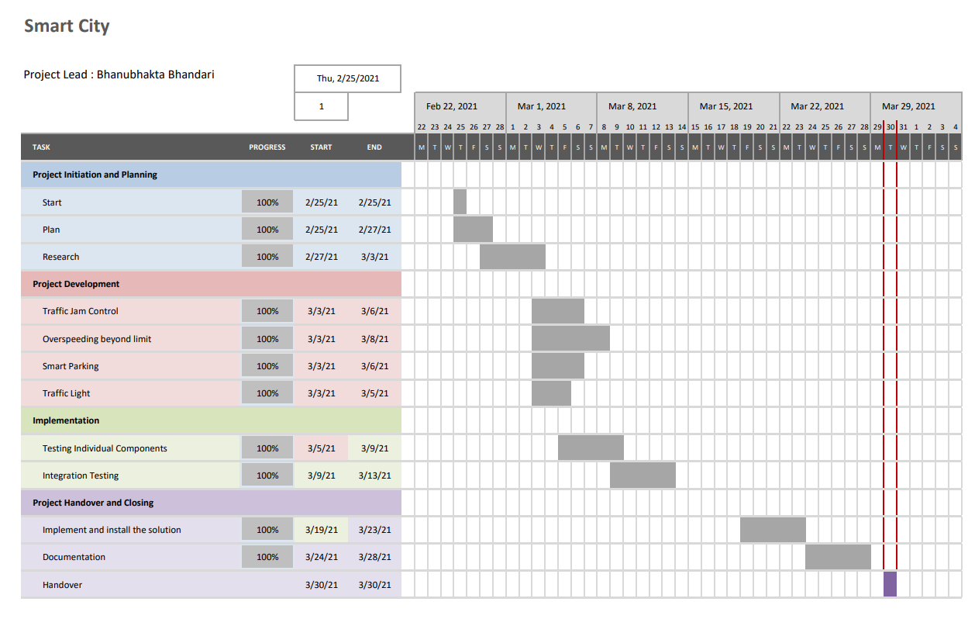

Figure 7: Schedule in Gant Chart

# Tools & Technologies Used

|  |  |  |  |
| --- | --- | --- | --- |
| **S.No.** | **Tools & Technologies** | **Function** | **URL** |
| **1.** | Storyboard | This is used for making story of problem. | <https://www.storyboardthat.com> |
| **2.** | Tinkercad | This website helps to make circuit design. | <https://www.tinkercad.com> |
| **3.** | Arduino IDE | It helps to program code into Arduino. | <https://www.arduino.cc/en/software> |
| **4.** | Firebase | It helps to store data in real time | <https://firebase.google.com> |

# System Design

The devices which are used for completing this project are as below:

1. **Arduino UNO:** It is one type of a microcontroller board which is based on ATmega328P. It consist of 14 digital pins, a USB port, a power jack, a reset button, 6 analog pins, an ICSP header and a 16MHz ceramic resonator. (Arduino Uno Rev3 | Arduino Official Store, 2021)

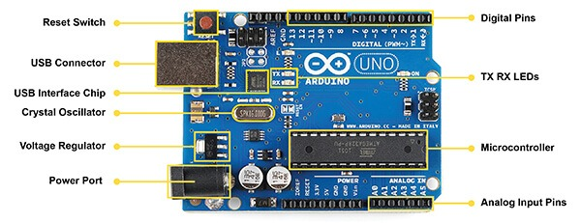

Figure 8: Arduino UNO

1. **Arduino Mega:** It is also a microcontroller board which is based on ATmega 2560. It consists of 16 analog pins, 14 for PWM outputs, a power jack, a Reset button, a crystal oscillator of 16MHz, a USB port and an ICSP Header. (Arduino Mega 2560 Board: Specifications, and Pin Configuration, 2021)

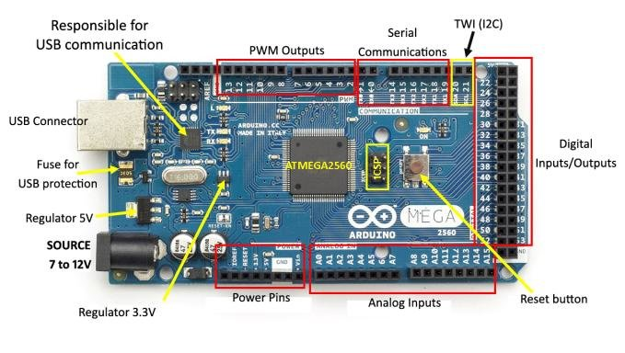

Figure 9: Arduino Mega

1. **NodeMCU (ESP 8266):** NodeMCU is mainly designed and built for IoT projects and applications which is based on Lua and open source firmware. Already embedded firmware which runs on ESP8266 Wifi SoC and hardware based on ESP-12E module in it. It has 128 KB RAM and flash memory of 4MB for storing programs. It supports SPI, I2C interface and UART. (NodeMCU ESP8266 Pinout, Specifications, Features & Datasheet, 2021)

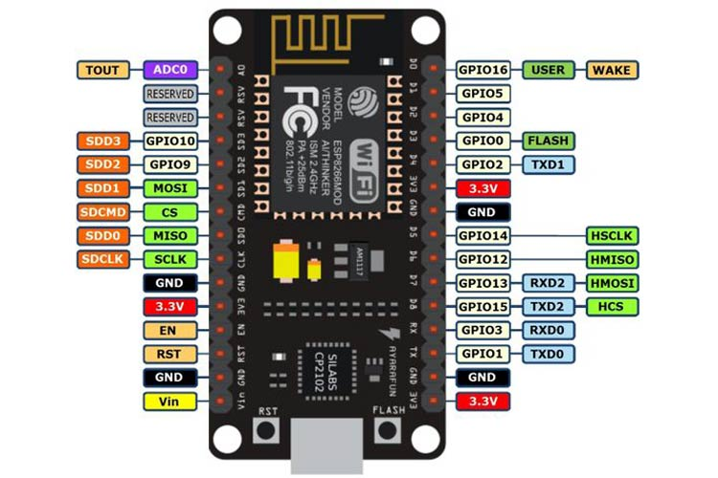

Figure 10: NodeMCU (ESP8266)

1. **Ultrasonic Sensor:** It is used for measuring distance of targeted object through emitted ultrasonic sound waves and converting that reflected sound waves from object into electrical signal. It has two main parts: **transmitter** which uses piezoelectric crystals for emitting sound and **receiver** receives that reflected sound waves from targeted object.

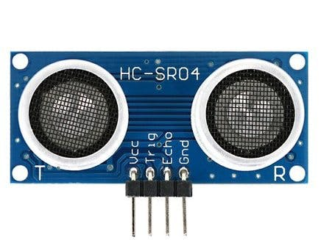

Figure 11: Ultrasonic Sensor

1. **RFID Sensor:** It is a mechanism which enables tracks wireless range and object identification. All the process interacts between a reader and tag which is fixed on an object. This type of sensor are used mainly for identification purpose. These tags can be activated from power supply from battery and collecting their energy sent by reader from RF signal. (What is RFID and How Does RFID Work? - AB&R®, 2021)

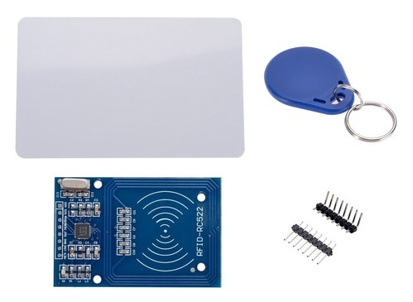

Figure 12: RFID Reader and Tag

1. **IR Sensor:** IR sensor are those microchips consisting of photocell which are especially active to infrared light. The main advantage of using this sensor is that it uses low power, design simply and with simple features. It emits to sense object near its range.

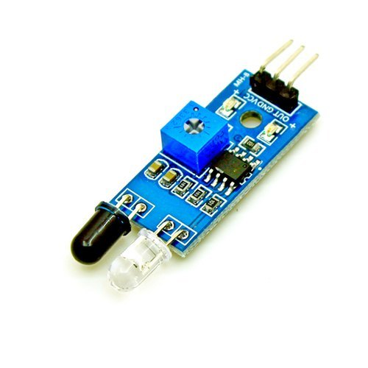

Figure 13: IR Sensor

1. **Servo Motor:** Servo motor is one kind of a motor which rotate with great accuracy. It consist of control circuit which provide information on recent position of motor stick and this information helps servo motors for rotating with accuracy. (What is a Servo Motor? - Understanding the basics of Servo Motor Working, 2021)

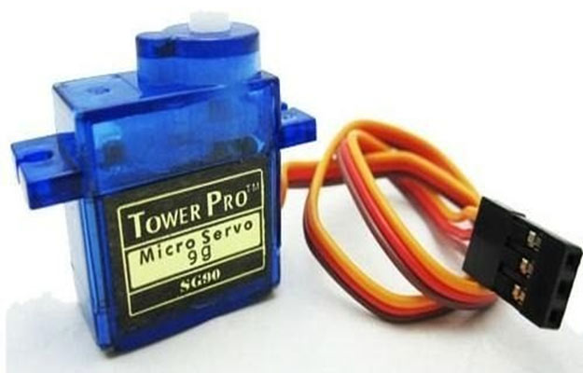

Figure 14: Servo Motor

1. **LED Display:** It is an electronic display board which is used for displaying some message to viewers.

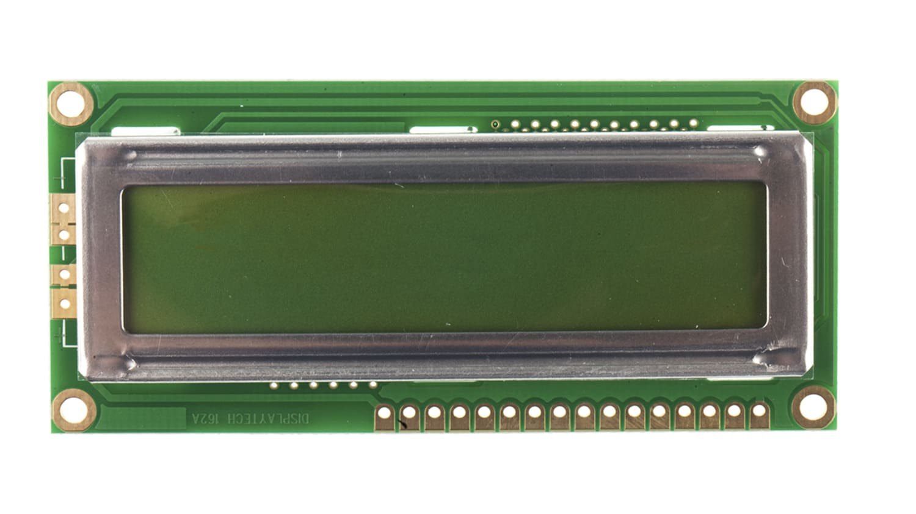

Figure 15: LED Display

1. **Breadboard:** Breadboard is a device which is used for just simply prototyping electric circuit with soldering. It helps to connect jumper wire from components to components without soldering which helps to look circuit clear.

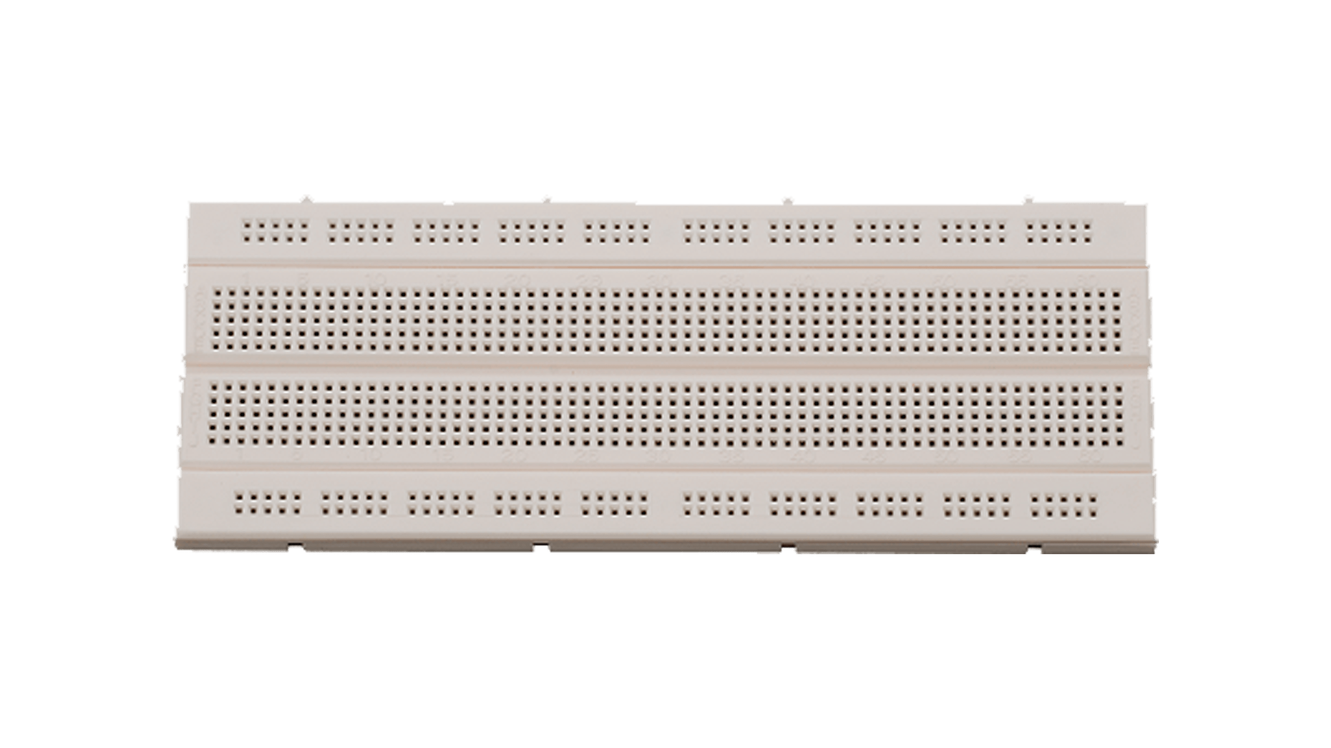

Figure 16: Breadboard

1. **LED Light:** LED (Light Emitting Diode) is an electrical device emitting light when current flows through it. There are different colours of LED in present days. It has two pins: one is cathode and another is anode.

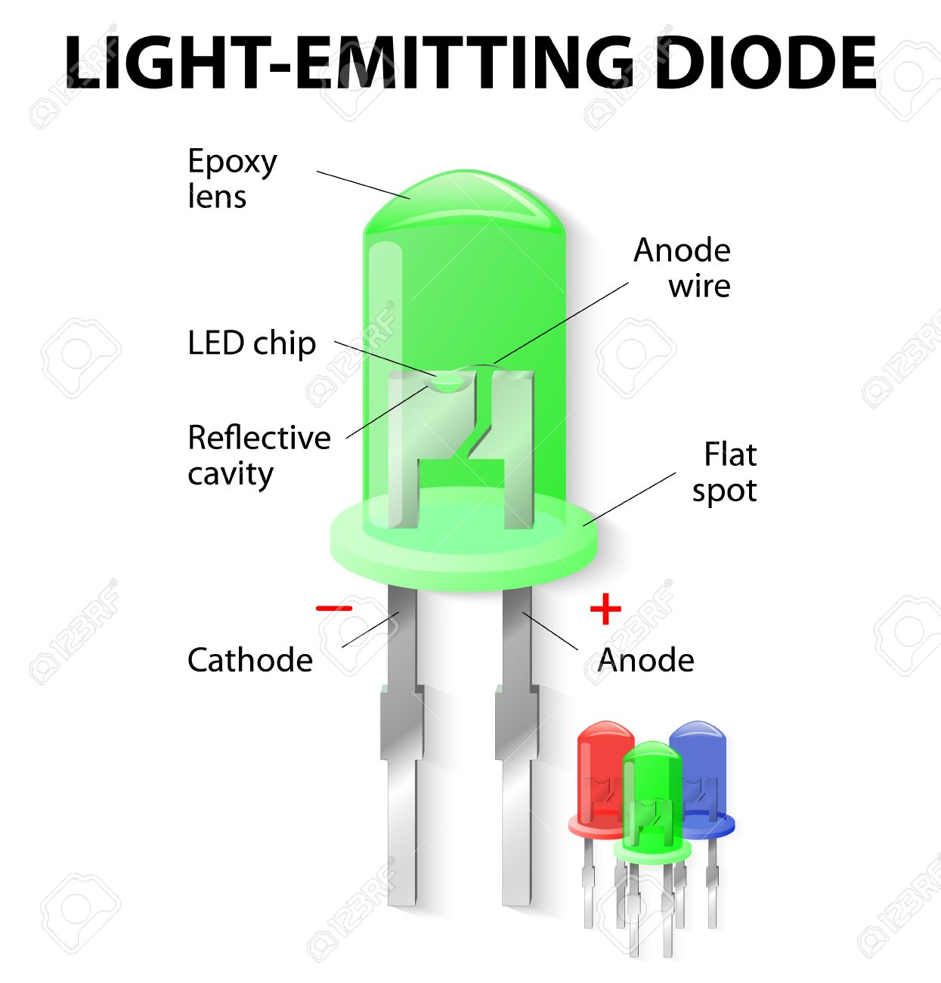

Figure 17: LED

1. **Jumper Wire:** Jumper Wire is used to connect two electrical components with or without using breadboard. There are three types of Jumper wire as:

* Male to Male
* Male to Female
* Female to Female

Female to Female

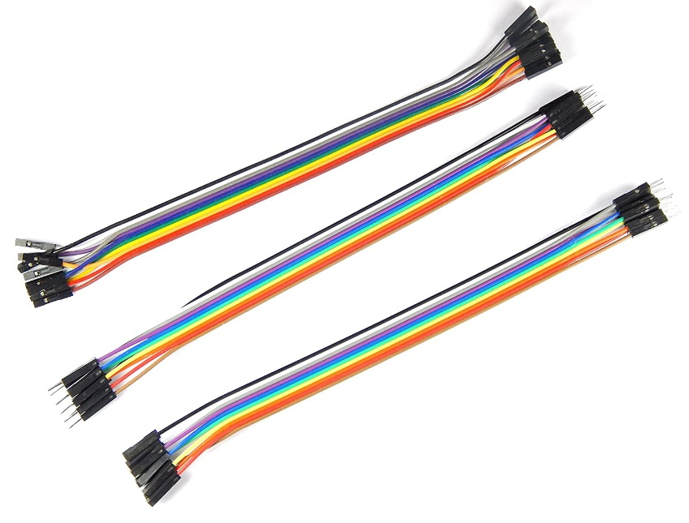

Male to Female

Male to Male

Figure 18: Jumper Wire

# Working Mechanism

To build the working project four controllers are used. Two Node MCU, Arduino UNO and Arduino Mega. Node MCU acts as a microcontroller which has a Wi-Fi module to for transferring data to internet. Every pin in the sensors is connected to the different pins in the microcontroller using bread board and power is given from the ground pin. Power supply to the Node MCU is given through laptops and adapter of 5V is used for both Arduino UNO and Arduino Mega. As data is transferred through WIFI module it gets stored in Firebase which shows and stores live data sensed by the sensor.

Project made have the features of traffic congestion diversion, Over Speeding data collection and smart parking whose working mechanism are described below.

1. Traffic Congestion Diversion: Two Ultrasonic sensors are used to detect the congestion. If both sensors sense the vehicle density for certain time, then it detects traffic congestion and close the barrier and alerts the traveler by showing message to the LCD.
2. Over Speeding Tracking: Here RFID tag is used when a vehicle with RFID tag or card travel over the sensor with the speed more than 10 km/hr. then the data gets stored in the Firebase with the speed travelled by the vehicles along with the vehicle number.
3. Smart Parking: To detect a car coming to the parking IR sensor is used. IR sensor detects the car and opens the barrier if the space is available inside the parking. Driver already gets to know whether there is space available inside the parking by looking at the LCD screen outside the parking. If there is no space inside, then message is shown with “No Space Available” in the screen.

# Sketch

The sketch used in the project is provided below,

## Smart Parking

Figure 19: Sketch 1

Figure 20: Sketch 2

Figure 21: Sketch 3

Figure 22: Sketch 4

## Speed Detection

Figure 23: Speed detection 1

Figure 24: Speed Detection 2

Figure 25: Speed Detection 3

Figure 26: Speed Detection 4

## Congestion detection

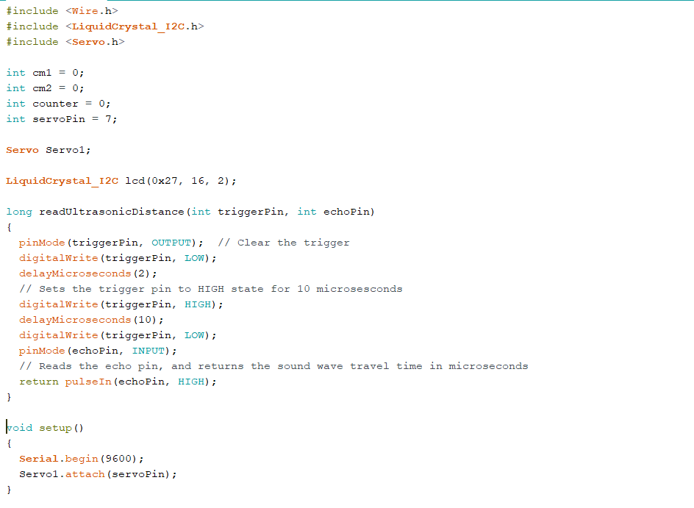

Figure 27: Congestion detection 1

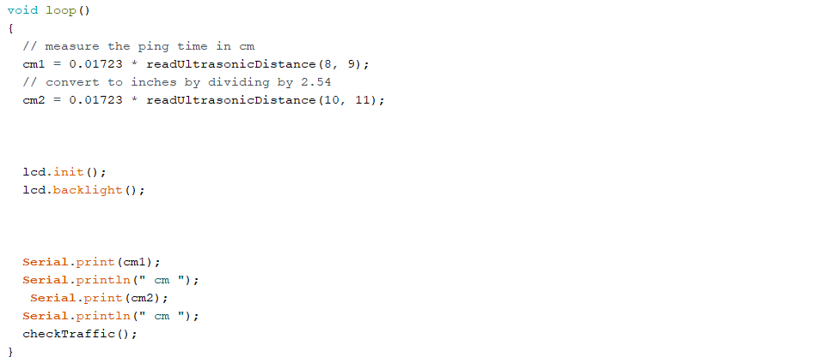

Figure 28: Congestion detection 2

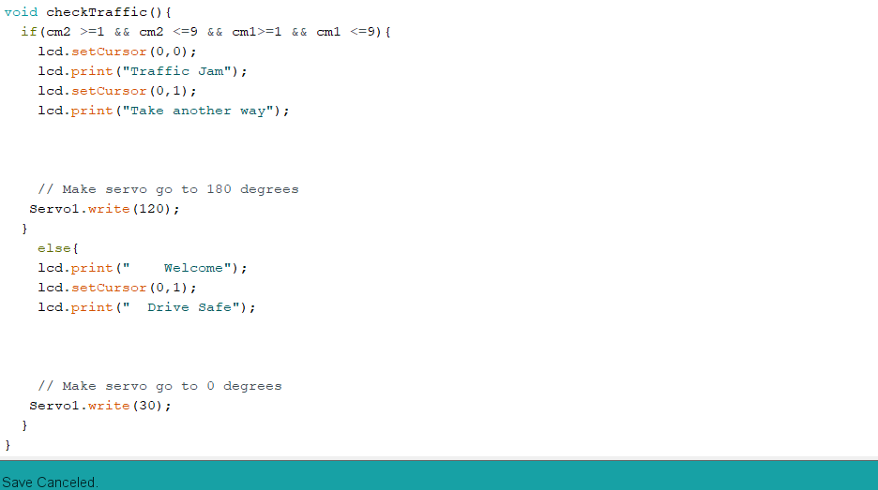

Figure 29: Congestion detection 3

## Traffic Light

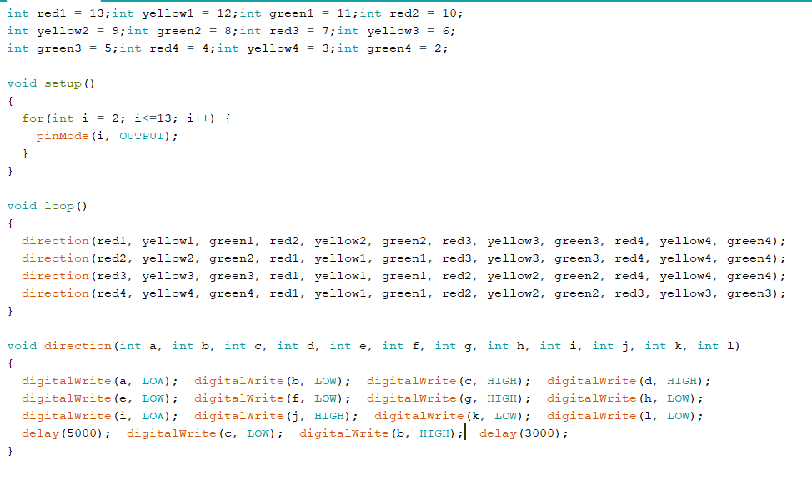

Figure 30: Traffic light 1

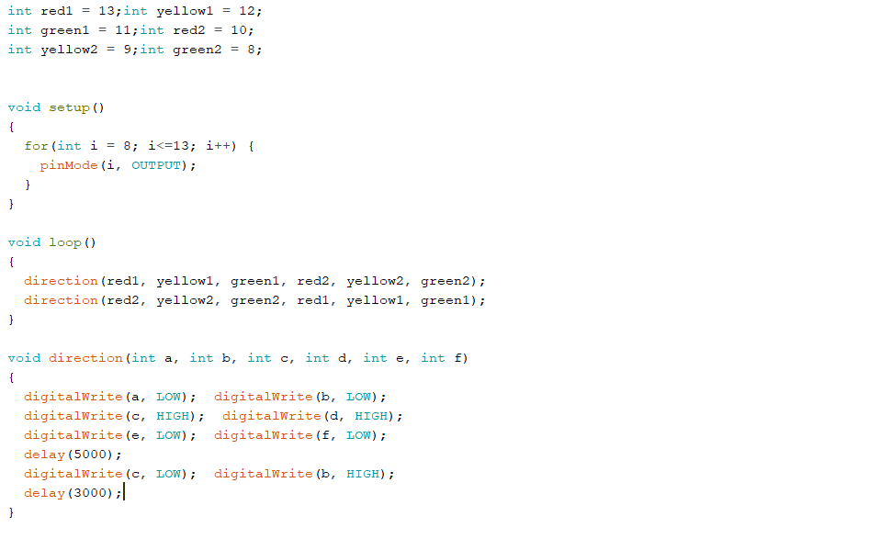

Figure 31: Traffic light 2

# Block Diagram

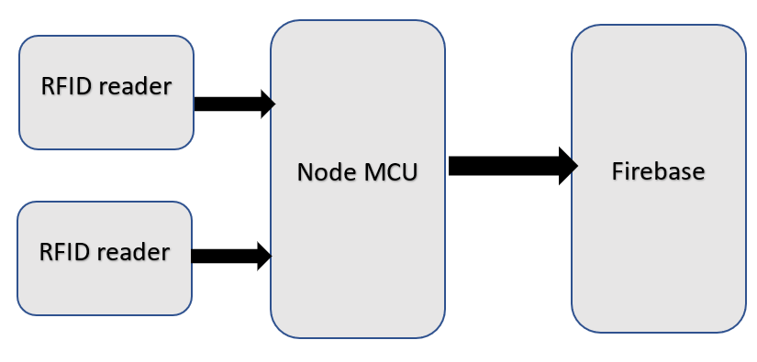

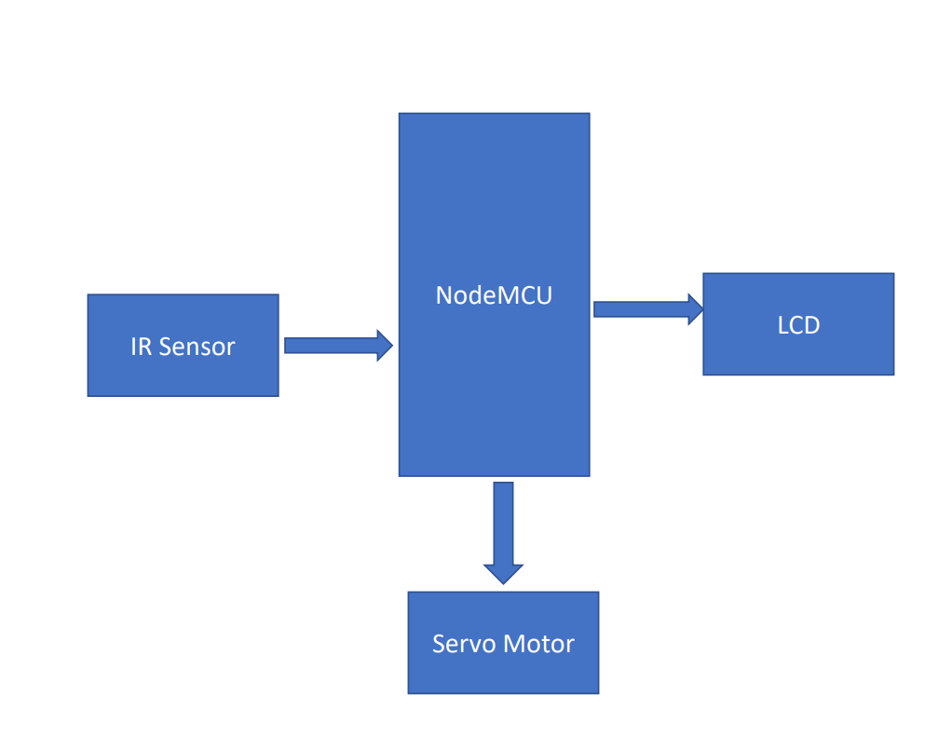Figure 33: Block Chain Diagram of speed detector

Figure 32: Block Chain Diagram for smart parking

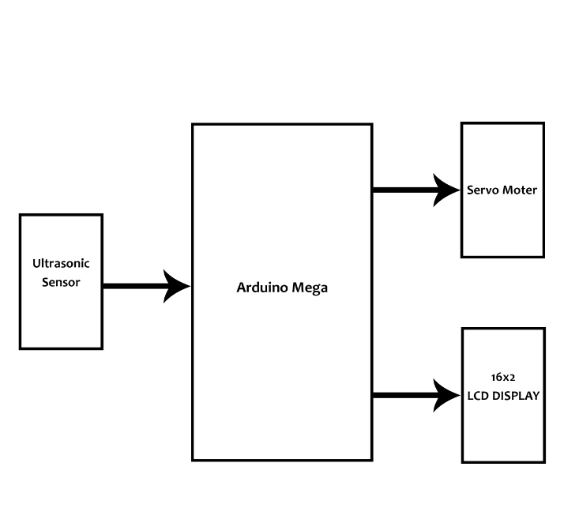

Figure 34: Block Chain Diagram for Congestion management system

# Development

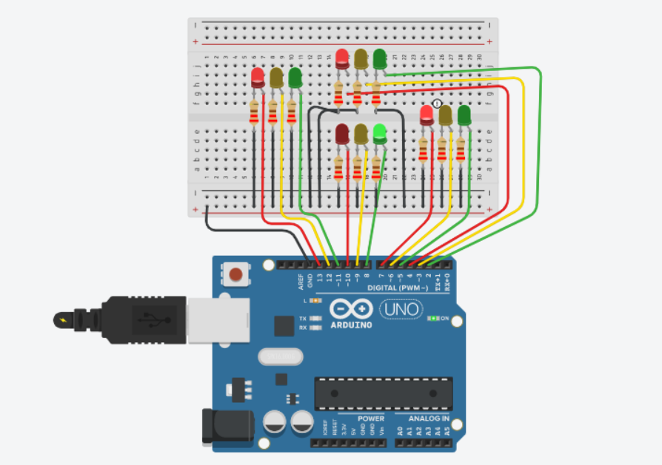

Figure 35: Circuit Diagram for Traffic Light

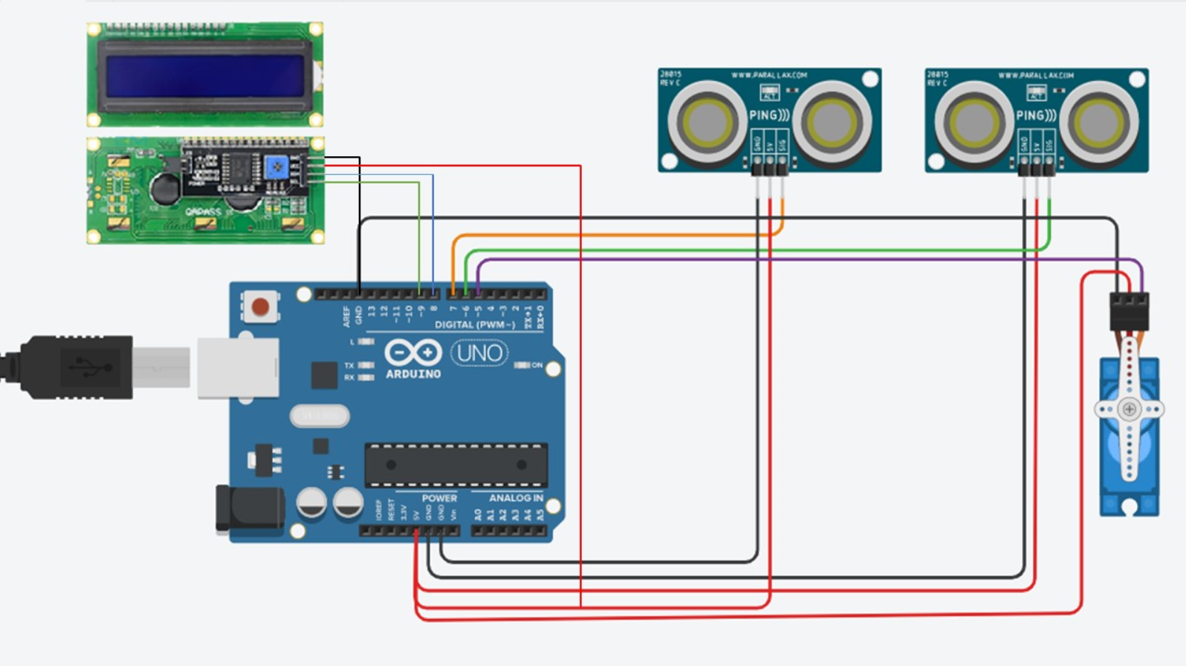

Figure 36: Circuit Diagram for Congestion management

Figure 37: Circuit Diagram for Overspeed Detector

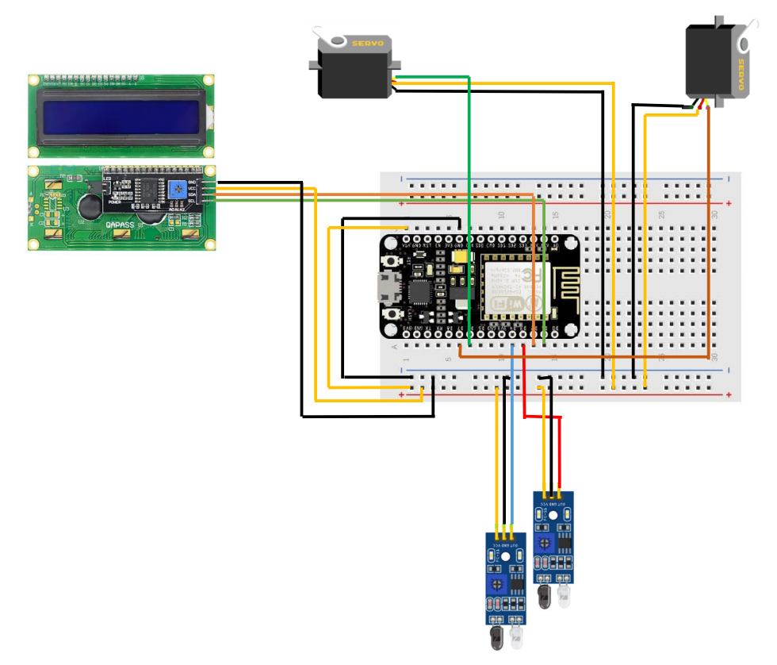

Figure 38: Circuit Diagram for Smart Parking

# Testing

To confirm and know if the designed system works as expected or not we had done testing which includes. We did not get success in our first attempt, we had to try it for more than three times. Due to many wires, devices and pin we get confused and have connected pins incorrectly which we found during testing and solved. We faced more and more problems as we move forward after solving each problems but we tried hard to find the solution and solved the problem. While using node MCU for sending data to the firebase as Real time database, we faced problem with our Wi-Fi connection and range. At first we have used hotspot for node MCU connection but due to its low range we were failed to get the speed of the vehicle. Later on after connecting node MCU with main router we were successful to get the data i.e. this time node MCU send data to the firebase. Likewise, we tested all the thing in our prototype like tested whether the ultrasonic sensors detect the traffic congestion or not and whether the barrier get down or not when there is congestion. The test was passed and successful. Incorrect pin connection again leads to the failure in our smart parking. Due to congested wires it was quite hard to fix the problem but later we got that and were able to run the prototype as expected.

# Troubleshooting

1. Node MCU may stop working.

* Make sure to connect node MCU with the main router otherwise with hotspot it may not work.
* Make sure to check if there are any loose connection.

1. Node MCU may not work.

* Make sure the ESP8266 library is installed in the sketch.
* Check the node MCU model and respective library.

1. RFID reader is not reading the RFID tags and RFID cards.

* Check connection and make sure the connection is same as in the circuit diagram.

1. LCD does not display the message as expected.

* Check the connection from LCD to Arduino.
* Check V0 pin of LCD is connected to potentiometer.

1. Servo motor is not working.

* Check the connection.
* Check the initialized angles in the sketch.

# Future Work

Although we have done many things to solve the current issue of our city there are also other things that can be implemented and the prototype could be updated in the future. For now, we have used RFID to detect the speed with vehicle tracking but in future we can use them to detect the position of vehicle, to count the number of vehicles in the city, to manage traffic according to the flow of traffic detected by the sensors in a specified area. Likewise, we can improve many things from our prototype as for now there is one parking place with capacity of five vehicle. Later in the future we can build and display different parking with location and available space in a mobile app or any website which will save lot of our time. Similarly, congestion detection system can be upgraded by changing the sensors or replacing with camera module and can be programmed in machine level for accurate result.

# Conclusion

And finally, we were successful to design and build the planed prototype exploring problem of people in city area due to traffic congestion along with the solution. In this way, an idea with a prototype to maintain the traffic system inside a city was made using different sensors was made to make a smart city with smart traffic system. The system made can help the people travelling notifying them the congestion traffic ahead, control increasing over speeding and accident occurring with it, manage the unmanaged parking smoothly and help traffic manpower to manage traffic inside the city easily.

Appendices

YouTube Link: https://youtu.be/X9kQt3AlCi4